**Detailed Features**

1. **Registration:**

* You can click on the link to register for a customer, enter all the necessary valid information then submit and you can login to the website as a customer.
* The registration form:

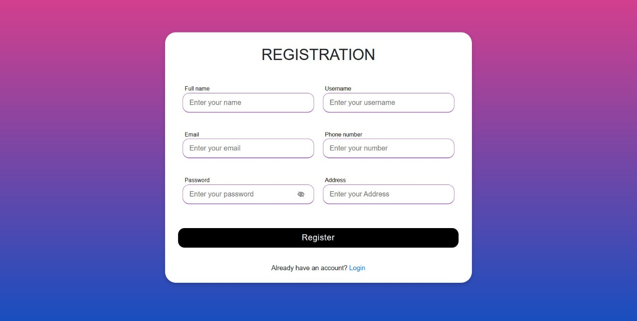

1. **Login:**

* After successful registration, you can log in to be able to save the product information that you have added to the cart. From there you can order and purchase.
* The login form will be like this:

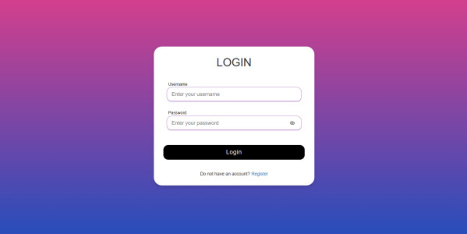

1. **Shopping:**

* After successful registration and login, you can click on the product, view and add to cart

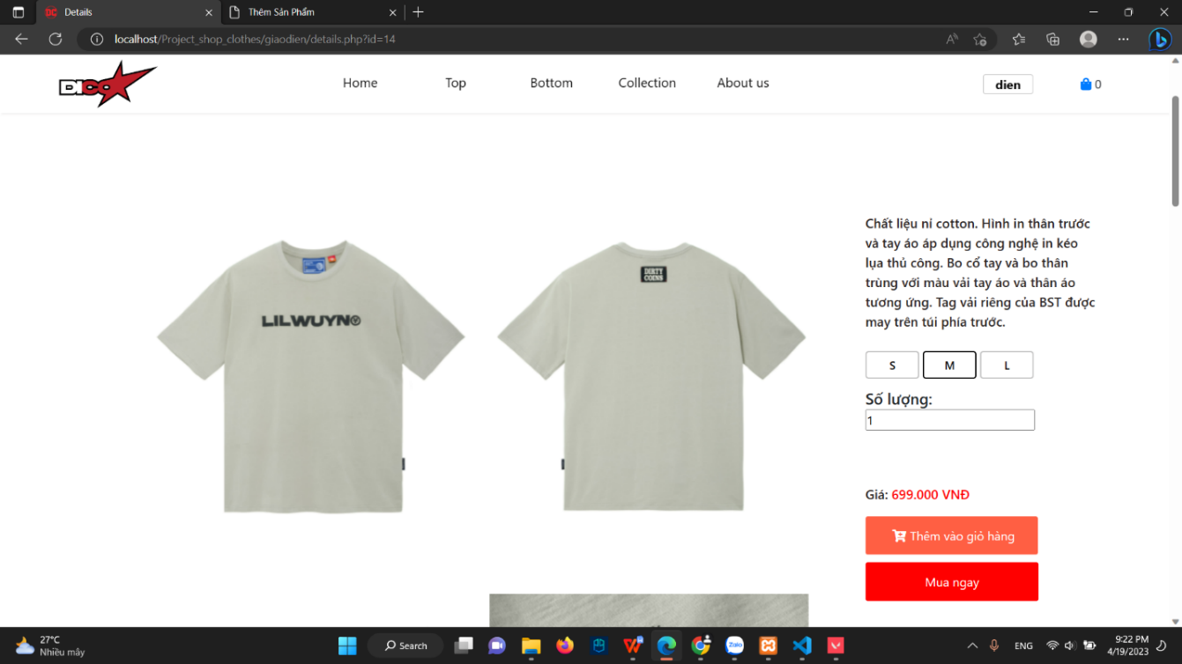

* The number of products that you add to the cart will be displayed here



1. **Rating:**

* **This is the feature where you can rate our products, you can leave comment and star review about the product**

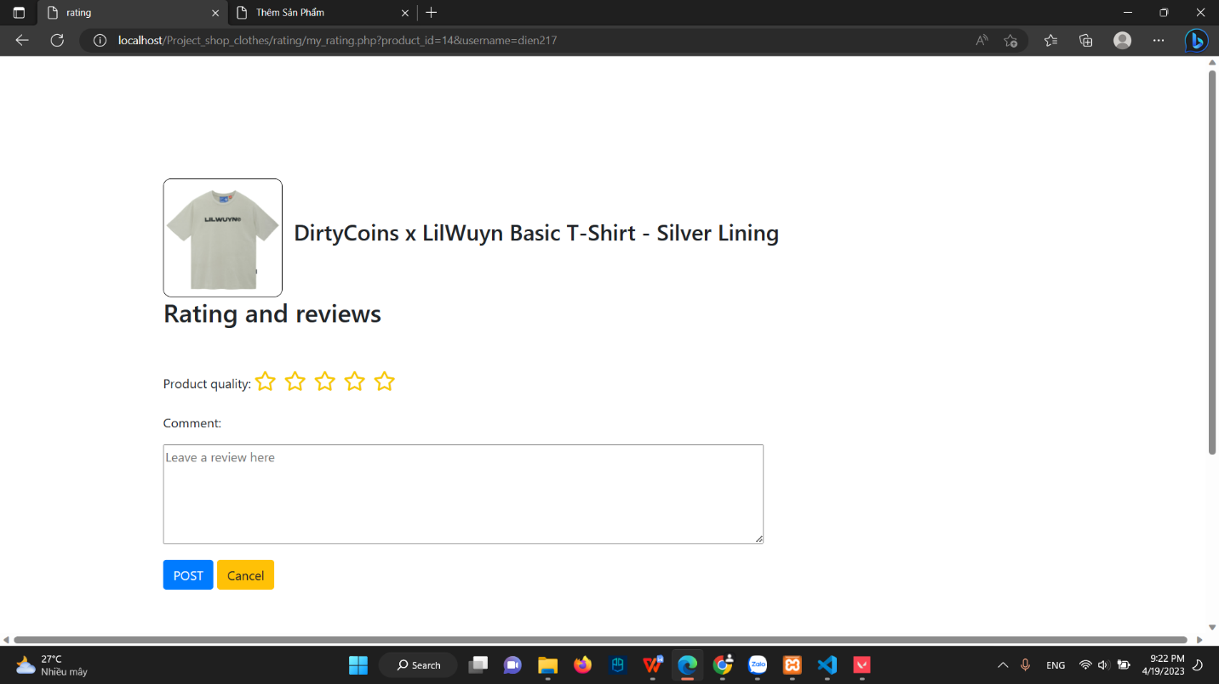

1. **Filter:**

* **You can search type of**